**7376 HW3**

**Name: Xuebao Zhao NUID: 002108354**

**Problem1:**

|  |  |  |  |  |
| --- | --- | --- | --- | --- |
| Index | Process | Virtual address | Size | Physical address |
| 0 | A | 0 | 1KB | 10240 |
| 1 | A | 2048 | 1KB | 3072 |
| 2 | A | 3072 | 1KB | 7168 |
| 3 | B | 1024 | 1KB | 2048 |
| 4 | B | 2048 | 1KB | 4096 |
| 5 | B | 3072 | 1KB | 9216 |

1. i., v. and vi. are valid virtual memory access addresses.

|  |  |  |  |
| --- | --- | --- | --- |
|  | Corresponding Segment Index | Offset | Physical address |
| i. | 1 | 100 | 3172 |
| iii. | 2 | 1023 | 8191 |
| v. | 4 | 0 | 4096 |
| vi. | 5 | 200 | 9416 |

**Problem2:**

|  |  |  |  |
| --- | --- | --- | --- |
|  | Is valid or not | Physical address | process |
| 1. 29 | No |  |  |
| 1. 123 | Yes | 507 | B |
| 1. 16 | Yes | 16 | A |
| 1. 90 | No |  |  |
| 1. 10 | Yes | 10 | A |

The allocate of virtual memory and physical memory are showed in the graph. If the virtual address is within the range of 0 to 19 or within the range of 108 to 127, it is valid. Add the correspond offset can get the physical address.

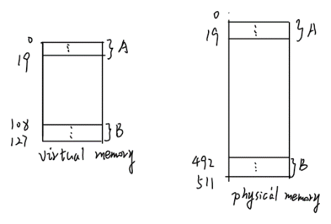

**Problem3:**

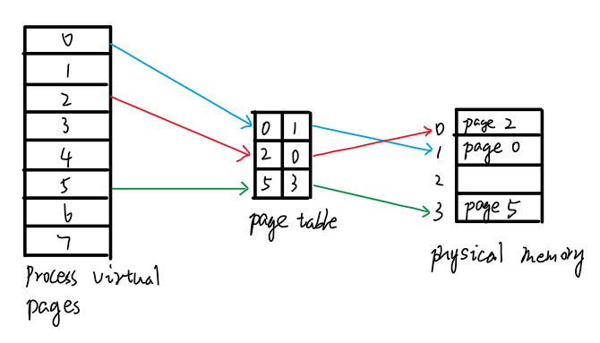

1. 256 bytes pages means the page offset needs 8 bits, and there are 8 pages which needs 3 bits. So, the Virtual Address needs (8 + 3) = 11 bits to represent.

256 bytes pages means the page offset needs 8 bits, and there are 4 frames which needs 2 bits. So, the Physical Address needs (8 + 2) = 10 bits to represent.

Because the pages are 256 bytes, the offset needs 8 bits. (28 = 256)

1. 418 D = 001 1010 0010 B

VPN = 001 B = 1 D

There is no page1 in the page table. So, 418 doesn’t exit.

0 D = 000 0000 0000 B

VPN = 000 B = 0 D 🡪 PFN = 1 D = 001 B

Offset = 0000 0000 B

So, the Physical Address = 001 0000 0000 = 256 D

581 D = 010 0100 0101 B

VPN = 010 B = 2 D 🡪 PFN = 0 D = 000 B

Offset = 0100 0101 B

So, the Physical Address = 000 0100 0101 = 69 D

460 D = 001 1100 1100 B

VPN = 001 B = 1 D

There is no page1 in the page table. So, 460 doesn’t exit.